**COLLABORATIVE PROJECT WITH INTEL**

**PROJECT TITLE : Smart Mobile Phone Price Prediction using Machine Learning**

**TEAM NAME :** **Triumvirate**

**Team Mentor : Dr T V RAJINI KANTH, Professor & Head,**

**Department of CSE-AI&ML**

[**rajinikanthtv@sreenidhi.edu.in**](mailto:rajinikanthtv@sreenidhi.edu.in)**,**

[**rajinitv@gmail.com**](mailto:rajinitv@gmail.com)**,**

**Ph. No: 9849414375**

**Team Members : NAALLA VENKATESHWARLU** Roll no:21311A6606 CSE-AIML(Team lead)

**MALLA VENKATA SAI ASHISH** Roll no: 21311A6602 CSE-AIML

**THAKUR JAYANTH SINGH** Roll no: 21311A6604 CSE-AIML

**Institute Name** **:** **Sreenidhi Institute of Science and Technology**

**Yamnam Pet, Ghatkesar**

**Hyderabad - 501301**

**Date of submission :** **10 -07- 2023**

**ABSTRACT:** In this Modern Era, Smartphones are an integral part of the lives of human beings. When a smartphone is purchased ,many factors like the Display, Processor, Memory, Camera, Thickness, Battery, Connectivity and others are taken into account . One factor that people do not consider is whether the product is worth the cost .

Based on the accuracy , the appropriate algorithm has been used to predict the prices of the smartphone. This not only helps the customers decide the right phone to purchase , it also helps the owners decide what should be the appropriate pricing of the phone for the features that they offer

Different feature selection algorithms are used to identify and remove less important and redundant features and have minimum computational complexity. Ref[4]

Different classifiers are used to achieve the best possible accuracy. Results are measured in terms of achieving the maximum accuracy and choosing the minimum features.Ref[3]

***Keywords: Machine learning, Random forest, Mobile cost prediction,Smartphone price prediction,Price prediction***

**INTRODUCTION**

Machine learning algorithms can perform various tasks which are to be chosen with respect to the data to be worked with and the motive of the task. Various tools and languages like Python, MATLAB, Java, WEKA, Cygwin, Octave, etc are available to perform machine learning tasks. Examples of some frequently used algorithms include Naïve Bayes, K-NN, etc. Feature selection algorithms can be used to select and extract only the best parameters to train a model to optimize the accuracy and lessen the computational time of the model. Any of these methods can be used to perform the task of predicting the price of a product depending on the type of data available to train the model.

**MOTIVATION**

The rapidly evolving mobile phone industry has made it increasingly challenging for consumers to make informed purchasing decisions due to the vast array of options available. Smartphones vary greatly in terms of features, specifications, and, most importantly, prices. As a result, there is a growing need for a reliable and efficient method to predict mobile phone prices accurately.

A potential answer to this problem is machine learning, which can analyse massive amounts of data and discover patterns. We can create a prediction model that predicts the pricing of prospective mobile phone releases using historical data on smartphone features and their corresponding costs.

Our project aims to empower consumers by accurately predicting mobile phone prices, enabling informed purchasing decisions based on the alignment of price with features and specifications. This benefits users, helping them avoid overpaying or missing out on great deals. Additionally, stakeholders like manufacturers, retailers, and analysts can leverage price predictions for competitive pricing, inventory management, and gaining market insights.

Ultimately, the motivation for this project lies in enhancing the overall consumer experience by providing a valuable tool that simplifies the process of choosing the right mobile phone based on budgetary considerations. By leveraging the power of machine learning, we can enable individuals to navigate the complex mobile phone market with confidence and make informed decisions about their purchases."

The Intel Industrial Training initiative Unnati Program helps the students in getting the flavour of Industrial View of the work planning, interaction and guidance of Intel Team and friendly competing with other students from different parts of the world.

**DATA SOURCES**

For our project, we undertook the task of scraping mobile phone details from Gadget 360, meticulously organizing the collected data to create our own comprehensive dataset. This involved extracting the necessary information and arranging it systematically. In the end, we successfully compiled a robust dataset consisting of over 8000 records, encompassing 36 essential features. This extensive dataset serves as a valuable foundation for our analysis and predictive modeling

So we have the following features in our dataset Brand, no_of_rear_camera, rear_camera_1_pixels, no_of_front_camera, front_camera_1_pixels, Release_year, Screen-size, operationg_system, Internal_storage(GB), WiFi, Bluetooth, Battery(mah), RAM, Touchscreen, Form-factor, Processor, GPS, Resolution, Accelerometer, Proximity_sensor, Ambient_light_sensor, Expandable_storage, Rear_flash, Proceesor_make, Height, Breadth, Width, Price_in_India, Weight, Compass/magnetometer, Headphones, Gyroscope, Expandable_storage_type, 4G_or_3G, Simtype, GSM/CDMA, Expandable_storage

We trained a model to analyze features and provide accurate price estimations, demonstrating our dedication to precision and innovation.

We developed a user-friendly web interface using Streamlit, ensuring that our project can be easily accessed and utilized by anyone.

**PYTHON LIBRARIES USED IN THE PROGRAMS**

**Numpy-** NumPy is a fundamental library for numerical computing in Python. It provides support for efficient and multidimensional arrays, along with a wide range of mathematical functions. NumPy is essential for creating and modifying arrays, performing mathematical operations on arrays, and handling large datasets efficiently.

**Pandas-** Pandas is a versatile library for data manipulation and analysis. It provides data structures like DataFrames that allow for easy handling and manipulation of structured data. Pandas is commonly used for cleaning and preprocessing data, transforming data into desired formats, and performing various data analysis tasks.

**Seaborn-** Seaborn is a statistical data visualization library built on top of Matplotlib. It provides a high-level interface for creating informative and visually appealing statistical graphics. Seaborn simplifies the process of creating various types of plots, such as scatter plots, bar plots, box plots, and heatmaps. It can also assist in identifying outliers in the data through visualizations.

**matplotlib-** Matplotlib is a widely-used plotting library in Python. It offers extensive flexibility for creating static, animated, and interactive visualizations. Matplotlib enables the creation of a wide range of plots, from simple line plots and histograms to complex 3D visualizations. It is often used in conjunction with other libraries, such as NumPy and Pandas, to visualize data and identify outliers.

**Sklearn-** Scikit-learn is a comprehensive machine learning library that provides various algorithms and tools for data analysis and modeling. It includes implementations of popular machine learning algorithms, such as regression, classification, clustering, and dimensionality reduction. Scikit-learn also offers utilities for data preprocessing, model evaluation, and model selection.

**JobLib-** Joblib is a library in Python that provides tools for efficiently saving and loading Python objects, especially large NumPy arrays. It is commonly used in conjunction with scikit-learn to store trained machine learning models and avoid retraining them from scratch.

**ARCHITECTURE**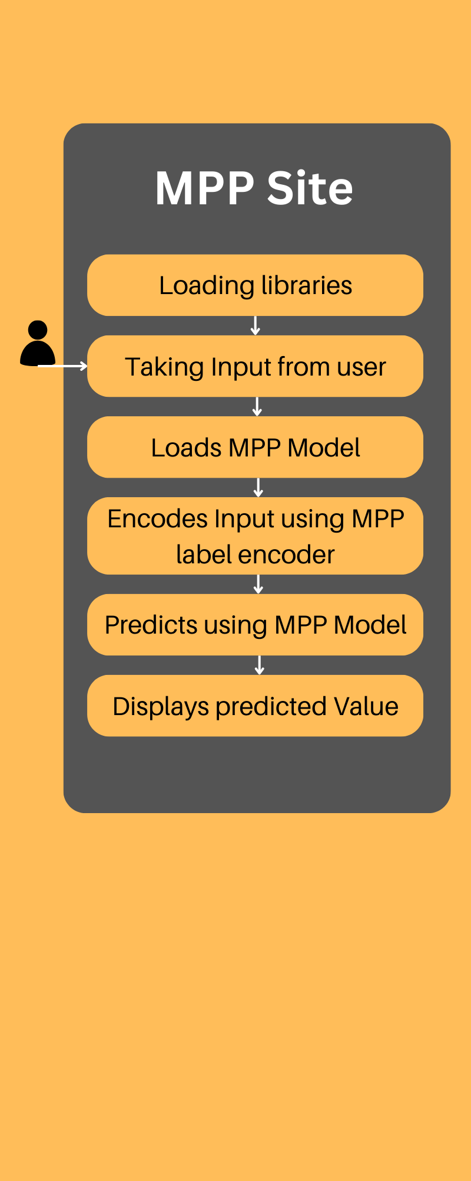

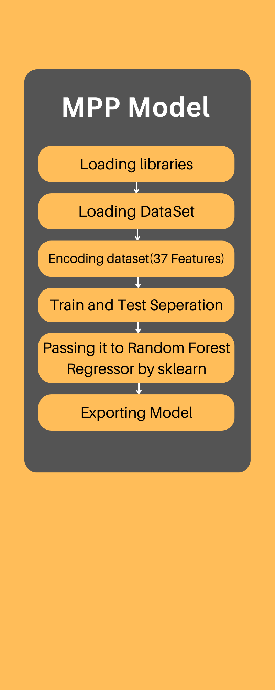

**Fig 1 Fig 2**

**Fig.1: Architecture diagram of MPP Site**

**Fig.2: Architecture diagram of MPP Model**

**RESULTS**

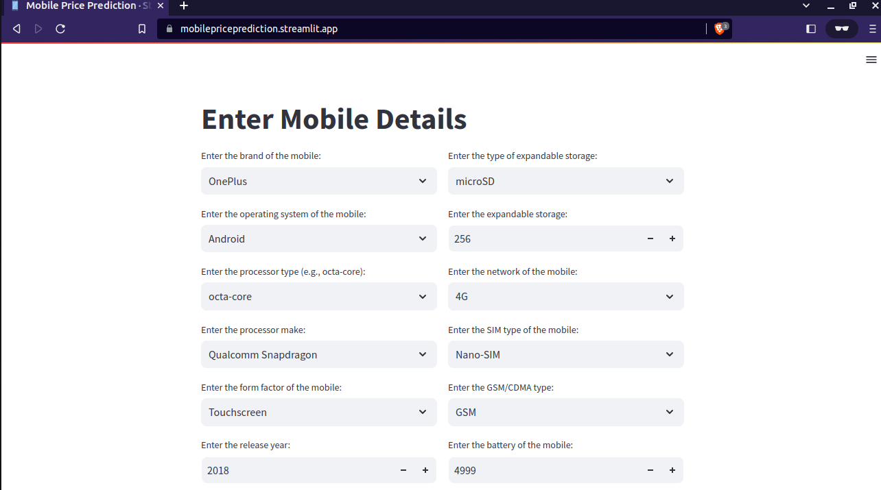

Fig 3

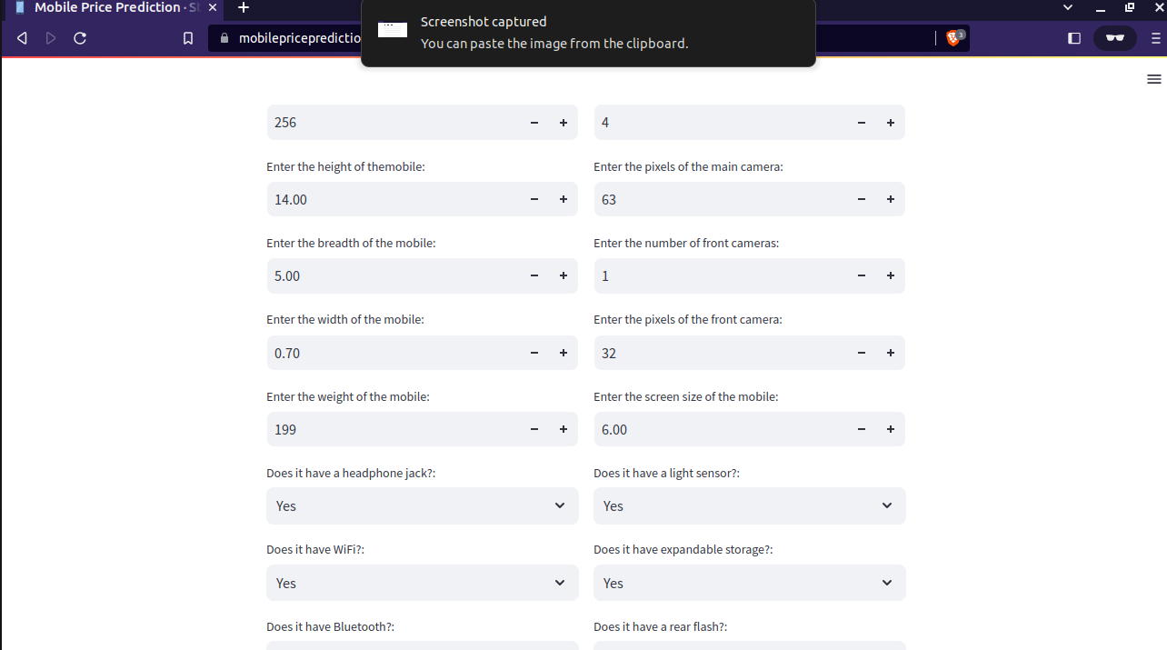

Fig 4

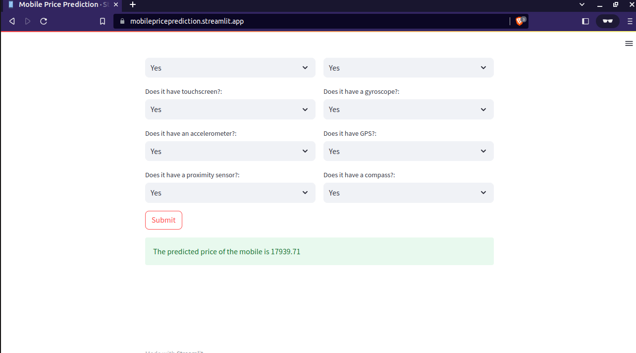

Fig 5

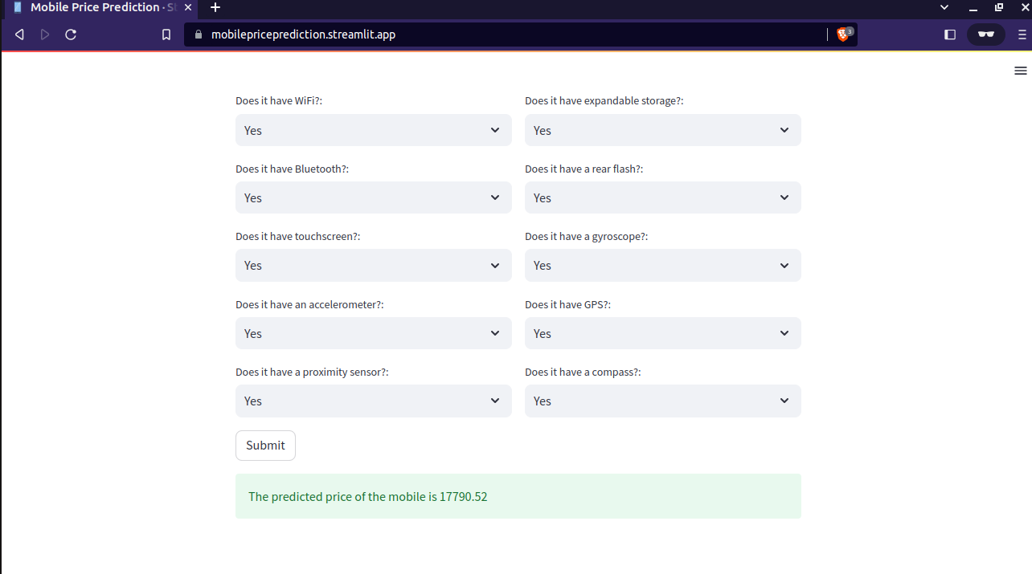

Fig 6

**CONCLUSION:**

In conclusion, our project on smart mobile phone price prediction using machine learning has successfully empowered consumers to make informed purchasing decisions based on accurate price forecasts. By leveraging historical data and employing machine learning algorithms, we have developed a valuable tool that helps users assess the value of smartphones and avoid overpayment. Additionally, our project benefits industry stakeholders by providing insights into pricing strategies and market trends. With a user-friendly web interface, our project offers accessible and convenient access to our predictive model. Overall, our project enhances the consumer experience and contributes to a more informed mobile phone market.

**FUTURE SCOPE:**

Integrating advanced machine learning algorithms can improve the reliability, accuracy, and functionality of the system in conjunction with other electronics. The system can analyse complicated data patterns, learn from interactions, and make intelligent decisions by using techniques such as deep learning and neural networks. Adding smartphones, tablets, smart home gadgets, and wearables to its capabilities will make it a versatile and indispensable tool in modern technology. Users will benefit from increased performance and convenience across different platforms, thus cementing its importance in the electronics industry.

**REFERENCES**

**[1] S. Subhiksha, Swathi Thota, J. Sangeetha: Prediction of Phone Prices Using Machine Learning Techniques. (09 January 2020)**

[**http://dx.doi.org/10.1007/978-981-15-1097-7_65**](http://dx.doi.org/10.1007/978-981-15-1097-7_65)

**[2]Nivitus : Mobile Price Prediction Using Machine Learning(July 2022)**

[**https://medium.com/@Nivitus./mobile-price-prediction-using-machine-learning-fa9cab6fb242**](https://medium.com/@Nivitus./mobile-price-prediction-using-machine-learning-fa9cab6fb242)

**[3] Pritish Arora, Sudhanshu Srivastava, Bindu Garg , ISSN: 2455-2631 Issue 4**

**Publishing date: Apr 2020**

[**https://www.ijsdr.org/papers/IJSDR2004057.pdf**](https://www.ijsdr.org/papers/IJSDR2004057.pdf)

**[4] Muhammad Asim, Zafar KhanMobile Price Class prediction using Machine Learning Techniques. International Journal of Computer Applications (0975 – 8887)**

**Volume 179 – No.29, March 2018**

**DOI:**[**http://dx.doi.org/10.5120/ijca2018916555**](http://dx.doi.org/10.5120/ijca2018916555)

**[5]Prateek Majumder —**

**Learn Mobile Price Prediction Through Four Classification Algorithms Published On February 23, 2022 and Last Modified On March 22nd, 2022**

[**https://www.analyticsvidhya.com/blog/2022/02/learn-mobile-price-prediction-through-four-classification-algorithms/**](https://www.analyticsvidhya.com/blog/2022/02/learn-mobile-price-prediction-through-four-classification-algorithms/)

**SOURCE CODE AND CONFIGURATION FILES**

1. [**https://github.com/W-A-R-L-U/intelrepo**](https://github.com/W-A-R-L-U/intelrepo)

**Live Web Site [Demo]**

1. [**https://mobilepriceprediction.streamlit.app/**](https://mobilepriceprediction.streamlit.app/)